Sejal Multipurpose Education Society’s
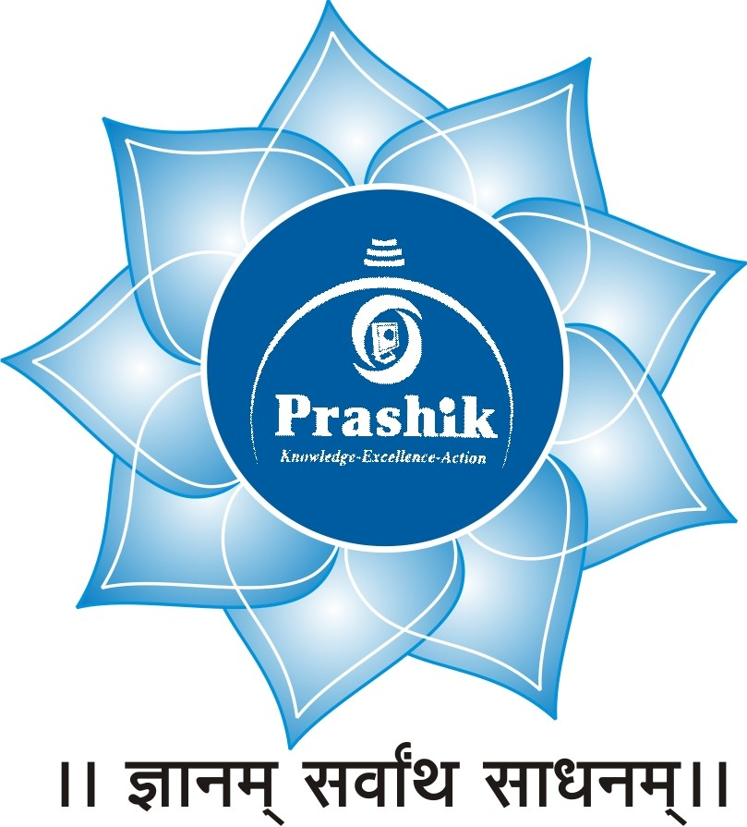
PRASHIK COLLEGE OF BCA & BCS
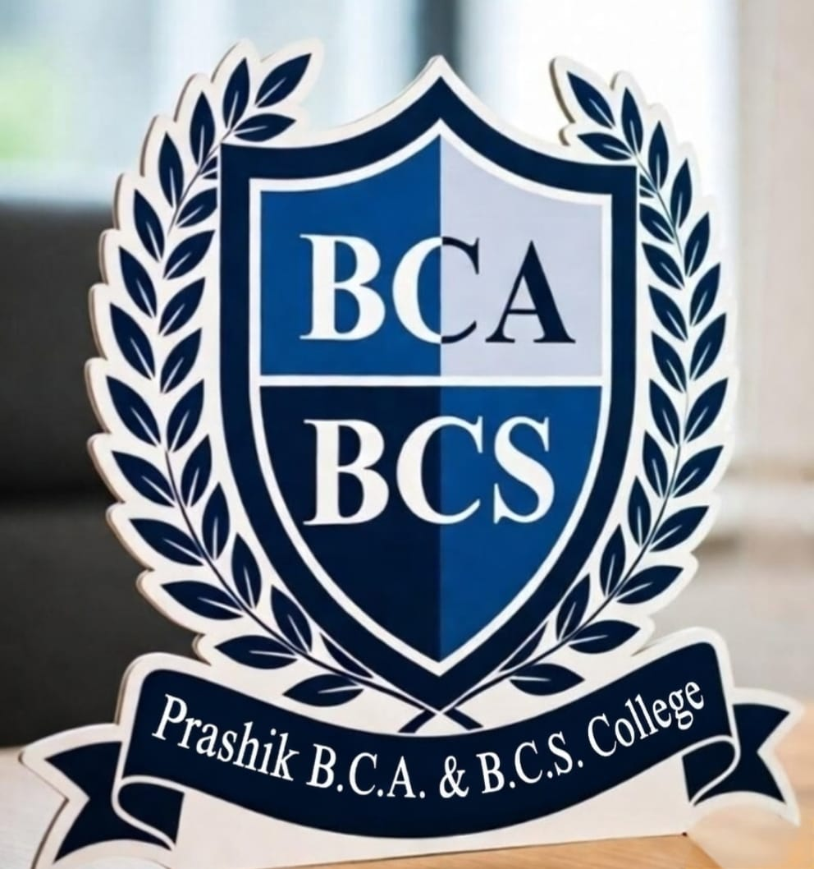
Minority Status June 2009
Plot No 141, Chawada Complex, Devlai Chowk, Chha Sambhajinagar
Mob. 9046512555/9422215556
www.prashikcollege.in Email: prashikcollegebcabcs@gmail.com
----------------------------------------------------------------------------------------------------------------Sejal Shankar Ambhore Sanket Shankar Ambhore
President Secretary
---------------------------------------------------------------------------------------------------------------
Ref. No. PCBCA&BCS/ Date: / /
REPORT ON SEMINAR: BASIC COMMUNICATION SKILLS
Date: 16th September 2025
Venue: Seminar Hall
Chairperson:
Dr. Rahul Tayade
Keynote Speaker:
Dr. Raj Korde

1. Introduction
A one-day seminar on "Basic Communication Skills" was organized on 16th September 2025. The session aimed to equip participants with essential verbal and non-verbal tools required for professional and personal excellence. The event was presided over by Dr. Rahul Tayade, who emphasized the growing necessity of soft skills in a competitive global environment.
2. Inaugural Session
The program commenced with a welcome address by the Chairperson, Dr. Rahul Tayade. In his opening remarks, Dr. Tayade highlighted that "communication is the bridge between confusion and clarity." He introduced the keynote speaker, Dr. Raj Korde, acknowledging his vast expertise in behavioural sciences and corporate training.
3. Key Highlights of the Session by Dr. Raj Korde
Dr. Korde delivered an interactive and insightful lecture focusing on the "7 Cs of Communication" and the psychology of effective interaction. Key topics included:
- Active Listening: Understanding the difference between 'hearing' and 'listening' to foster better empathy.
- Non-Verbal Cues: The impact of body language, eye contact, and tone of voice in reinforcing the spoken word.
- Overcoming Barriers: Identifying psychological and physical barriers that hinder clear messaging.
- Clarity and Conciseness: The importance of delivering direct and precise information to avoid ambiguity.
4. Interactive Workshop
The latter half of the session included role-playing exercises and mock scenarios facilitated by Dr. Korde. Participants practiced:
- Elevator Pitches: Briefly introducing themselves and their ideas.
- Conflict Resolution: Using "I" statements to navigate difficult conversations without escalating tension.
5. Conclusion and Vote of Thanks
The session concluded with a Q&A segment where participants addressed specific challenges in public speaking and formal writing. Dr. Rahul Tayade, in his concluding remarks, expressed satisfaction with the engagement levels and urged participants to treat communication as a lifelong practice rather than a one-time lesson.
The event ended with a formal vote of thanks to Dr. Prem Waghmare for his valuable time and to the organizing committee for the successful execution of the program.
