Sejal Multipurpose Education Society’s
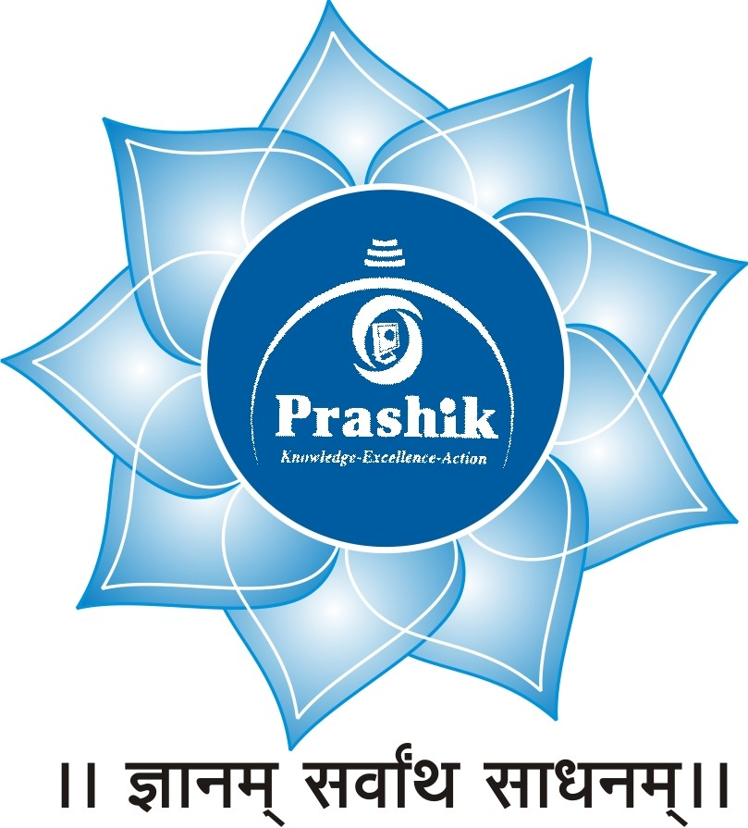
PRASHIK COLLEGE OF BCA & BCS
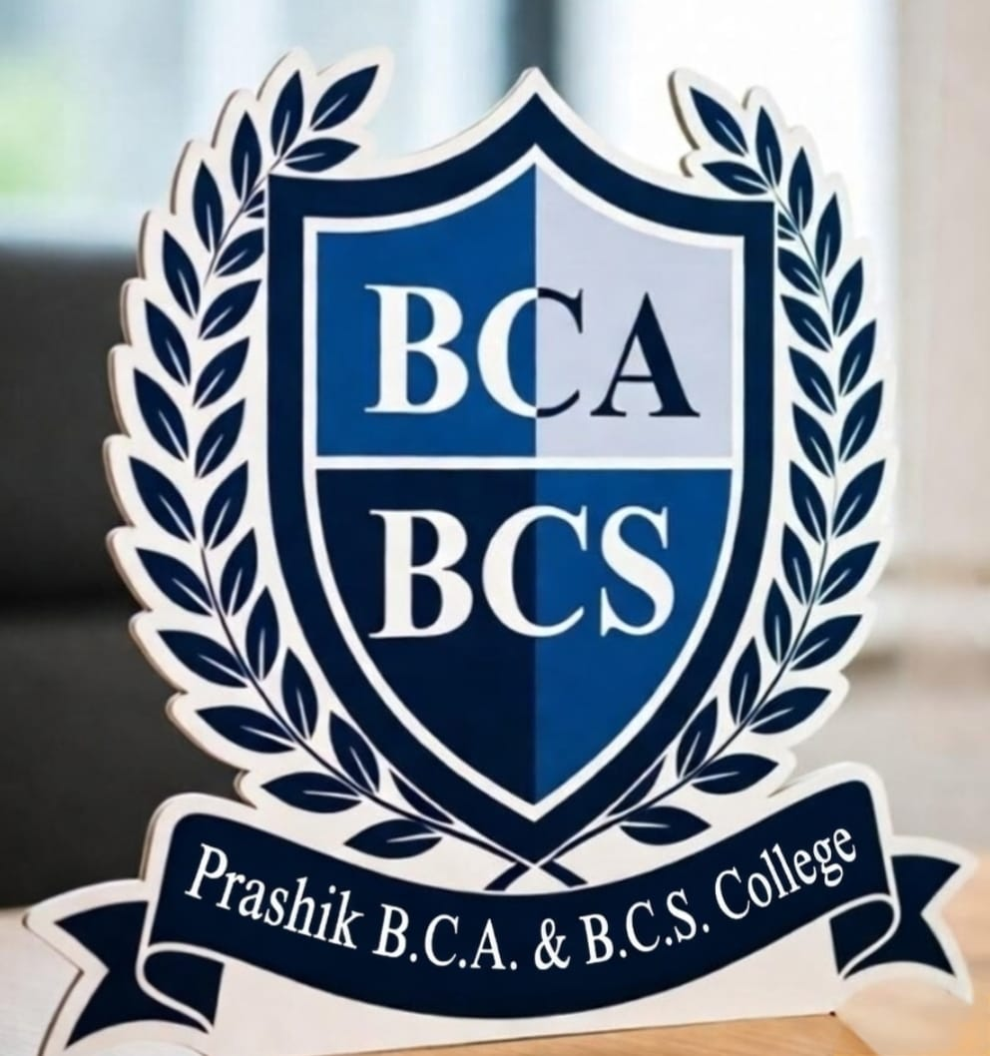
Minority Status June 2009
Plot No 141, Chawada Complex, Devlai Chowk, Chha Sambhajinagar
Mob. 9046512555/9422215556
www.prashikcollege.in Email: prashikcollegebcabcs@gmail.com
----------------------------------------------------------------------------------------------------------------Sejal Shankar Ambhore Sanket Shankar Ambhore
President Secretary
---------------------------------------------------------------------------------------------------------------
Ref. No. PCBCA&BCS/ Date: / /
Detailed Report on Communication Skills Seminar
Date: 1 December 2025
Chairperson: Dr. Rahul Tayde
Speaker: Dr. Vikram Dhanve
Introduction
A seminar on Communication Skills was organized on 1 December 2025 with the objective of improving students’ and participants’ ability to communicate effectively in personal, academic, and professional environments. The session aimed to highlight the importance of clear expression, active listening, confidence, and proper language use in everyday communication.
Chairperson’s Address
The seminar was chaired by Dr. Rahul Tayde, who inaugurated the session with an inspiring speech. He emphasized that communication is one of the most essential skills required for success in today’s competitive world. Dr. Tayde encouraged students to develop strong speaking and listening abilities, as effective communication helps in building relationships, teamwork, and leadership qualities.
Speaker’s Session
The keynote speaker, Dr. Vikram Dhanve, delivered an informative and engaging lecture on communication skills. He explained the basic elements of communication, including sender, message, medium, receiver, and feedback. He also discussed the types of communication such as verbal communication, non-verbal communication, written communication, and visual communication.
Dr. Dhanve highlighted several important aspects of effective communication:
Clarity and simplicity in language
Confidence while speaking
Proper body language and eye contact
Active listening skills
Importance of tone and pronunciation
He also provided practical examples and real-life situations where good communication skills can help in interviews, presentations, and professional life.
Interactive Session
The seminar included an interactive question-and-answer session where participants actively asked questions related to improving public speaking, overcoming stage fear, and developing better listening skills. Dr. Dhanve provided useful tips and encouraged regular practice to enhance communication abilities.
The seminar concluded with a vote of thanks to the chairperson and the speaker for their valuable guidance. The program was highly informative and beneficial for all participants. It helped them understand the importance of communication skills and motivated them to improve their abilities for future success.
Outcome of the Seminar
Participants gained a deeper understanding of effective communication techniques and learned practical methods to improve their speaking, listening, and interpersonal skills.
